Case 3-ASIA-Indus-Female Figurine-Polos Headdress-Terracotta-3000 BCE
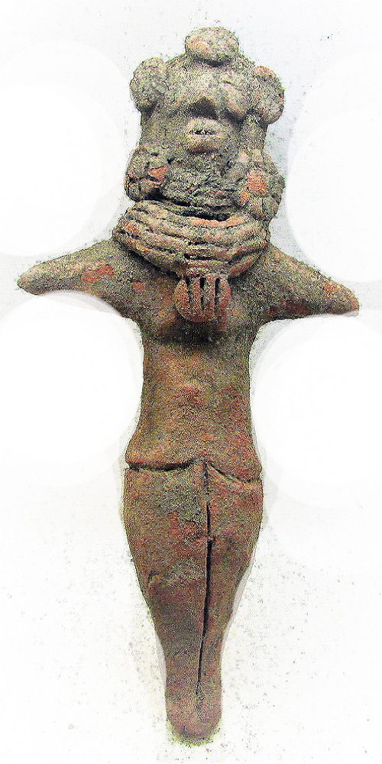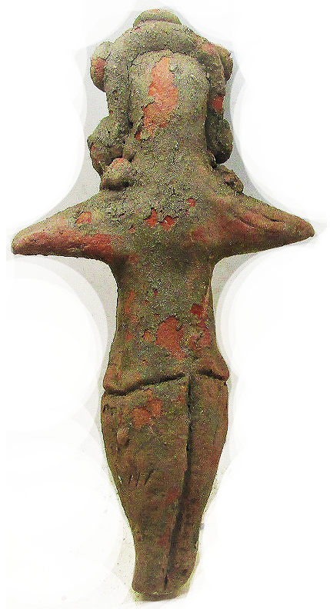

Fig. 1. ASIA-Indus-Female Figurine-Polos Headdress-Terracotta-3000 BCE Case no.: 3.
Accession Number: A….
Formal Label: ASIA-Indus-Female Figurine-Polos Headdress-Terracotta-3000 BCE
Display Description:
This Indus female figurine stylized facial features, long lappets of hair interspersed with flowers, necklace of four strands of beads, gorget of four strands of beads, tunic and slacks possibly of cotton, legs coming to a point without feet.
The Indus culture was spread over a vast area. Some important sites of this civilization are: Manda in Jammu and Kashmir; Shortughai in Afghanistan; Harappa in Western Punjab (Pakistan); Mohenjodaro and Chanhudaro in Sind; Kalibangan in Rajasthan; Lothal and Dholavira in Gujarat; Banawali and Rakhigarhi in Haryana; Daimabad in Maharashtra while Sutkagendor on the Makran Coast (near Pakistan-Iran border) is the western most site of the Harappan civilization and Alamgirpur in western Uttar Pradesh marks its eastern most limit. The location of settlements suggests that the Harappa, Kalibangan (On R Ghaggar Hakra generally associated with the paleo river Saraswati), Mohenjodaro axis was the heartland of this civilization and most of the settlements are located in this region. This area had certain uniform features in terms of the soil type, climate and subsistence pattern. The land was flat and depended on the monsoons and the Himalayan rivers for the supply of water. Due to its distinct geographical feature, agro-pastoral economy was the dominant feature in this region. Besides the urban settlements of the Harappans, there were many sites inhabited by the primitive communities consisting of stone-age hunter-gatherers or pastoralists. This figurine suggests that women held high positions both n the local communities and as goddesses who exemplified those aspects of the culture that were revered, such as this figurine adorned with flowers suggestive of fructification of the land.
Agriculture and pastoralism (cattle-rearing) the basis of the Harappan economy. Granaries at Harappa, Mohenjodaro and Lothal stored grains that included wheat, barley, sesasum, mustard, peas, jejube and rice from fields like those at Kalibangan, Banawali in Hissar district of Haryana. Agrigulture was aided by small scale irrigation wells or by diverted river water. Cotton was another important crop. A piece of woven cloth has been found at Mohenjodaro. Apart from cereals, fish and animal meat also formed a part of the Harappan diet.
LC Classification: PK119
Date or Time Horizon: 3000 BCE
Geographical Area: Indus Valley
INCLUDEPICTURE "https://upload.wikimedia.org/wikipedia/commons/5/50/Carte_Indus.jpg" \* MERGEFORMATINET 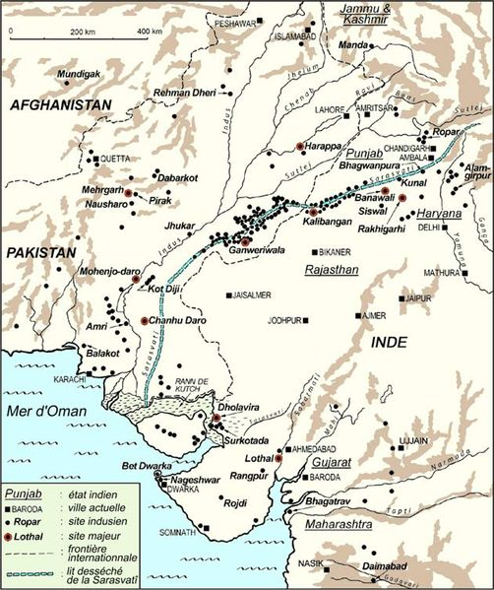
Cultural Affiliation: Indus Civilization
Media: terracotta, brown pigment
Dimensions: H 10.1 cm.
Weight:
Condition: original
Provenance: Ex: European collection
Discussion:
References:

Clark, S.R. 2003. “Representing the Indus body: sex, gender, sexuality, and the anthropomorphic terracotta figurines from Harappa,” Asian Perspectives, 42(2), pp.304-328.

